A Project Report on

Phase Shift Keying

Submitted by

**JASPREET SINGH BAHAL (ROLL NO. 05)**

**SAKINA BARANWALA (ROLL NO. 06)**

**PARTH BHATT(ROLL NO. 08)**

In fulfillment of

**Mini-Project for *OST***

In

**Electronics & Telecommunication Engineering**



Department of Electronics and Telecommunication Engineering

St. Francis Institute of Technology, Mumbai

University of Mumbai

(2018-2019)

**CERTIFICATE**

This is to certify that the project entitled **“**Phase Shift Keying**”** is a bonafide work of **“JASPREET SINGH BAHAL -05, SAKINA BARANWALA -06, PARTH BHATT-08”** submitted to the University of Mumbai in partial fulfillment of the course requirement for the award of the degree of **Bachelor of Engineering** in **Electronics and Telecommunication Engineering**.

Internal Examiner

**1. Introduction**

Phase Shift Keying (PSK) is a phase modulation scheme (conveys information overand carrier wave varying its instantaneous phase) in which digital information is transmitted through phase changes of carrier wave.Phase-shiftkeying (PSK) is a [digital modulation](https://en.wikipedia.org/wiki/Digital_modulation) process which conveys [data](https://en.wikipedia.org/wiki/Data#Uses_of_data_in_computing) by changing (modulating) the [phase](https://en.wikipedia.org/wiki/Phase_(waves)) of a constant [frequency](https://en.wikipedia.org/wiki/Frequency) reference [signal](https://en.wikipedia.org/wiki/Signal_(information_theory)) (the [carrier wave](https://en.wikipedia.org/wiki/Carrier_wave)). The modulation is accomplished by varying the [sine](https://en.wikipedia.org/wiki/Sine_wave) and [cosine](https://en.wikipedia.org/wiki/Cosine_wave) inputs at a precise time. It is widely used for [wireless LANs](https://en.wikipedia.org/wiki/Wireless_LAN), [RFID](https://en.wikipedia.org/wiki/RFID) and [Bluetooth](https://en.wikipedia.org/wiki/Bluetooth) communication. Any digital modulation scheme uses a finite number of distinct signals to represent digital data. PSK uses a finite number of phases, each assigned a unique pattern of [binary digits](https://en.wikipedia.org/wiki/Bit). Usually, each phase encodes an equal number of bits. Each pattern of bits forms the [symbol](https://en.wikipedia.org/wiki/Symbol_(data)) that is represented by the particular phase. The [demodulator](https://en.wikipedia.org/wiki/Demodulator), which is designed specifically for the symbol-set used by the modulator, determines the phase of the received signal and maps it back to the symbol it represents, thus recovering the original data. A convenient method to represent PSK schemes is on a [constellation diagram](https://en.wikipedia.org/wiki/Constellation_diagram). This shows the points in the [complex plane](https://en.wikipedia.org/wiki/Complex_plane) where, in this context, the [real](https://en.wikipedia.org/wiki/Real_number) and [imaginary](https://en.wikipedia.org/wiki/Imaginary_number" \o "Imaginary number)axes are termed the in-phase and quadrature axes respectively due to their 90° separation. Such a representation on perpendicular axes lends itself to straightforward implementation. The amplitude of each point along the in-phase axis is used to modulate a cosine (or sine) wave and the amplitude along the quadrature axis to modulate a sine (or cosine) wave.

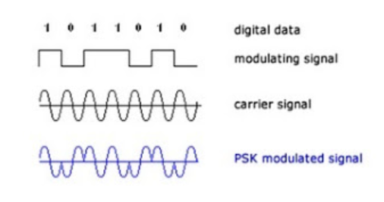

Figure 1: Waveformsof phase shift keying

**2. Scope of the Project**

The demodulation performance can be improved further by using PLL.

The bandwidth efficieny is lower, so it can be further be improved.

**3. PSK modulation**

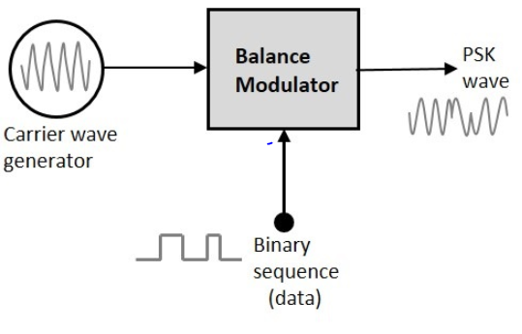

Figure 2: block diagram of PSK modulator

The block diagram of Phase Shift Keying consists of the balance modulator which has the carrier sine wave as one input and the binary sequence as the other input. Following is the diagrammatic representation. The modulation of PSK is done using a balance modulator, which multiplies the two signals applied at the input. For a zero binary input, the phase will be 0° and for a high input, the phase reversal is of 180°. The output sine wave of the modulator will be the direct input carrier or the inverted (180° phase shifted) input carrier, which is a function of the data signal.

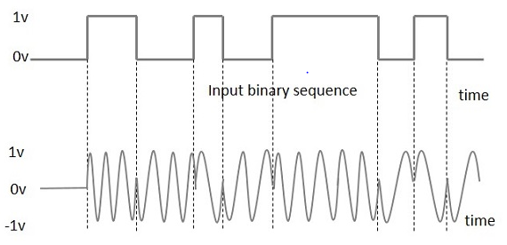

**4. Implementation in ltspice:**

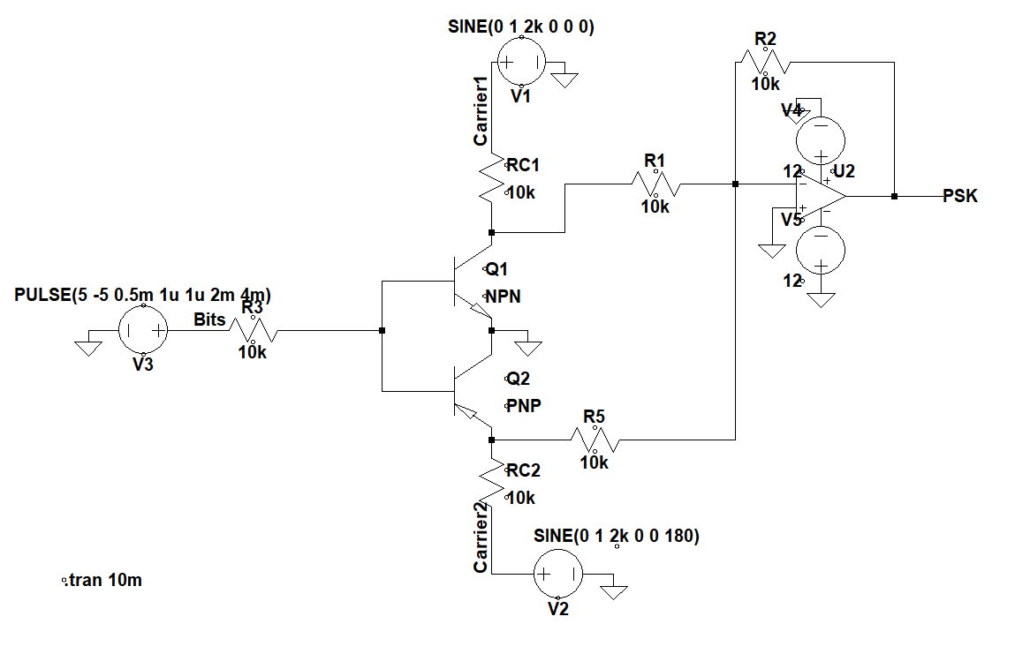

Figure 3: PSK modulation circuit daigram

**5. Theory of PSK modulation**

The transmitter circuit is built around CD4066B quad-bilateral switch (IC1), a digital pulse generator (XFG3), frequency oscillator (XFG1), phase changed frequency oscillator (XFG2) and 7404 hex inverter (IC2). Details of the source, frequency and nature of signals are given in the table.

|  |  |  |
| --- | --- | --- |
| **Source** | **Nature of signal** | **Specification** |
| XFG1/F1 | Sinusoidal wave a carrier1 1 | 10khz,1vpk-pk |
| XFG2/F2 | Sinusoidal wave a carrier2 | 10khz,1vpk-pk,180 degree |
| XFG3 | Square wave as data signal | 250hz,5vpk-pk |

Table 1: Input specifications of FSK circuit

A high-frequency sinusoidal signal from XFG1 is applied at pins 1 and 8 of IC1, which is controlled by binary data from XFG3 at pins 13 and 6 of IC1. A low-frequency signal from XFG2 is applied at pins 4 and 11 of IC1, which is controlled by binary inverted data applied at pins 5 and12 of IC1.The quad-bilateral switch (IC1) produces two amplitude shift keyed signals at pins 2 and 3, which are combined to get the phase shift keyed signal in XSC1. The receiver circuit is built around high-pass filters (R5 and C2), envelope detectors (D1, C1 and R1) and op-amp comparator circuits (R2, R3, D2, D3 and IC3). And thus the demodulation of the psk wave is done.

**6. Experimental Result**

The schematic, modulating signal and results of modulated output are shown in figure 4. In the circuit diagram in figure 3, there is an input pulse given to the bases of the bjt and two sinusoidal inputs to the collectors of the npn and pnp transisters of which one is of frequency 10khz and another is phase changed of frequency 10khz respectively. The universal op-amp compares the signals with the pulse signal , so when the output pulse is high the output waveform consists of 10khz frequency and when the output pulse is low the output waveform consists of 10khz phase changed frequency.

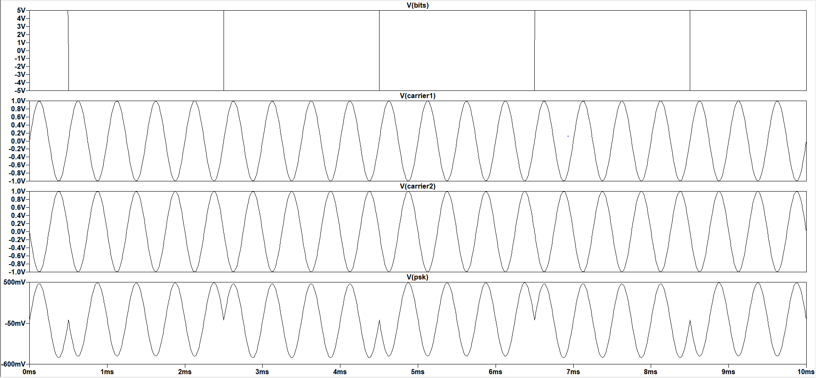

Figure 4: Modulated output of PSK

**7. Conclusion**

With the increasing sophistication of electronics and signal detection theory, it is clear that PSK modulators and demodulators can be utilised optimally modulate many different digital signal formats.In case of PSK probability of error is less. SNR is high. It is a power efficient system but it has lower bandwidth efficiency. PSK modulation is widely used in wireless transmission.The variants of basic PSK and ASK modulations are QAM, 16-QAM, 64-QAM and so on.

**8. References**

* <https://en.wikipedia.org/wiki/Phase-shift_keying>
* <https://www.tutorialspoint.com/digital_communication/digital_communication_phase_shift_keying.htm>
* <http://www.rfwireless-world.com/Terminology/ASK-vs-FSK-vs-PSK.html>